%Project Code for AM Modulation index determination
clear; close all; clc;
%Variable Declaration / Initialization
AM = [0.50,1];%Amplitudes for the two different message signals
AC = 1;%Amplitude for the Carrier Signal
mu = AM./AC;
freqM = 50;%Arbitrary Frequency for the Message Signal
wcM = 2*pi*freqM;
freqC = 10*freqM;%Arbitrary Frequency for the Carrier Signal
wcC = 2*pi*freqC;
fs = 10000;%Sampling rate
time = 0: 1/fs : 0.10;%Time Duration
carr = AC*cos(wcC*time);%Carrier signal
%Carrier Signal
figure();
plot(time,carr);
xlabel('Time (s)');
ylabel('Amplitude');
title('Carrier Signal');
cString = sprintf('Carrier | %g Hz', freqC);
legend(cString);
%Message Signal
figure('units','normalized','outerposition',[0 0 1 1])
messSig = zeros(length(AM), length(time));
messSigPha = zeros(length(AM), length(time));
for j = 1: length(AM)
subplot(1,length(AM),j)
messSig(j,:) = AM(j).*cos(wcM.*time);%Message Signal
messSigPha(j,:) = AM(j).*cos((wcM.*time) - (pi));%Message Signal
plot(time,messSig(j,:));
xlabel('Time (sec)');
ylabel('Amplitude');
tString1 = sprintf('Message Signal %g',j);
title(tString1);
lString1 = sprintf('AM %g | %g HZ', AM(j), freqM);
legend(lString1);
end
%Amplitude Modulated Signals
modSig = zeros(length(AM), length(time));
for j = 1: length(AM)
figure()
modSig(j,:) = (AC + AM(j).*cos(wcM.*time)).*cos(wcC*time);%Modulated Signal
hold on;
plot(time,modSig(j,:));
plot(time,(messSig(j,:) + AC), time, (messSigPha(j,:) - AC));
xlabel('Time (sec)');
ylabel('Amplitude');
tString2 = sprintf('Modulated Signal %g',j);
title(tString2);
lString2 = sprintf('\\mu | %g', mu(j));
legend(lString2);
end
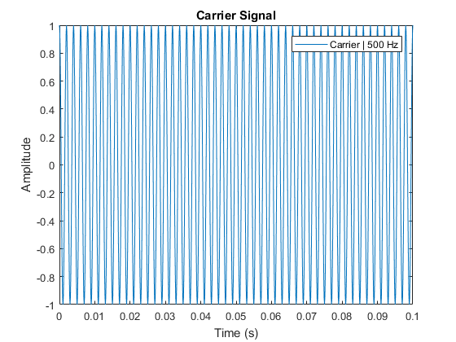
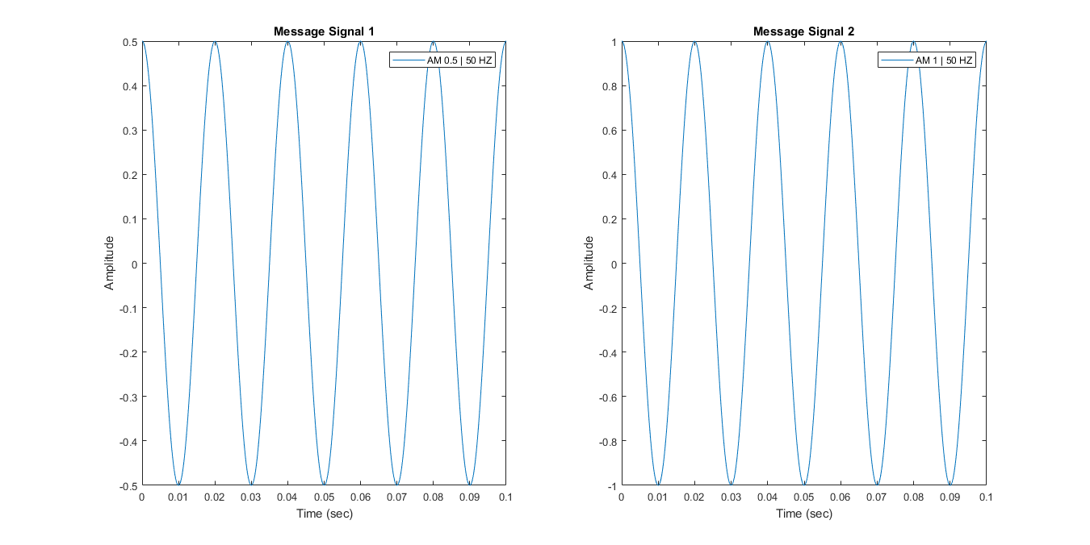
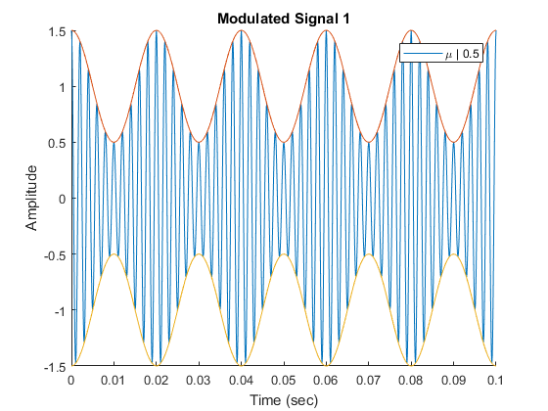
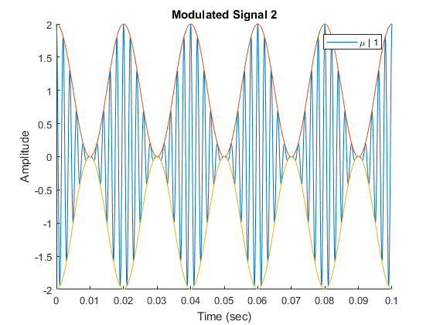
Published with MATLAB® R2017a

